**PAPER TITLE :-** The “Real-Time” Revolution for In situ Soil Nutrient Sensing

**DATE:-** February 17,2020

**JOURNAL/CONFERENCE:-** Journal of The Electrochemical Society, 2020 167 037569

**AUTHOR:-** Lamar Burton,1,z K. Jayachandran,2 and S. Bhansali1,

**PROBLEM MENTIONED/SOLUTION OBTAINED:-** N, P, and K are known to be responsible for assimilating proteins, synthesizing metabolic energy, and producing ATP. They are considered the most essential macronutrients. Although they natu rally exist in many forms throughout the soil environment, these nutrients are often exploited by humans in the form of fertilizers. Variations of soil nutrient and chemical composition are found spatially throughout agricultural farms and natural environments. These nutrient variations range from depleted soils to excessively fertile soils. As nutrients become limited, plants respond by reducing growth and altering their aspects for nutrient acquisition, utilization and morphology to maximize and acquire the limited resources.9 Whenexcess nutrients are available, those macro-nutrients which are not consumed by plants are leached into ground and surface waters during rainfall and irrigation events. Surface water uses mainly impacted by nutrient pollution include municipal and private water supplies, recreational waters for swimming and boating, cold and warm water fisheries, agricultural water supplies, and navigational waters. It has been noted that the accumulation of these nutrients in waters has harmful effects on humans10 and biodiversity,11 examples include cancer-causing drinking waters and decreased marine species population due to eutrophication. In addition, substantial economic loss and costs have been associated with excessive anthropogenic nutrient loading and harmful algal blooms (HAB’s). Declining fishing and boating activities as a result of nutrient pollution and HAB’s, has caused over $1 billion in losses each year to tourism. The EPA has also expressed their encouragement for states to immediately prioritize management actions for nutrient pollution in watersheds and water bodies.12 Thus, due to the impact of excess soil nutrients, there is a need for an affordable system that can continuously and accurately monitor soil conditions and move ment of their macronutrients in real-time.

**ALGORITHM USED:-**

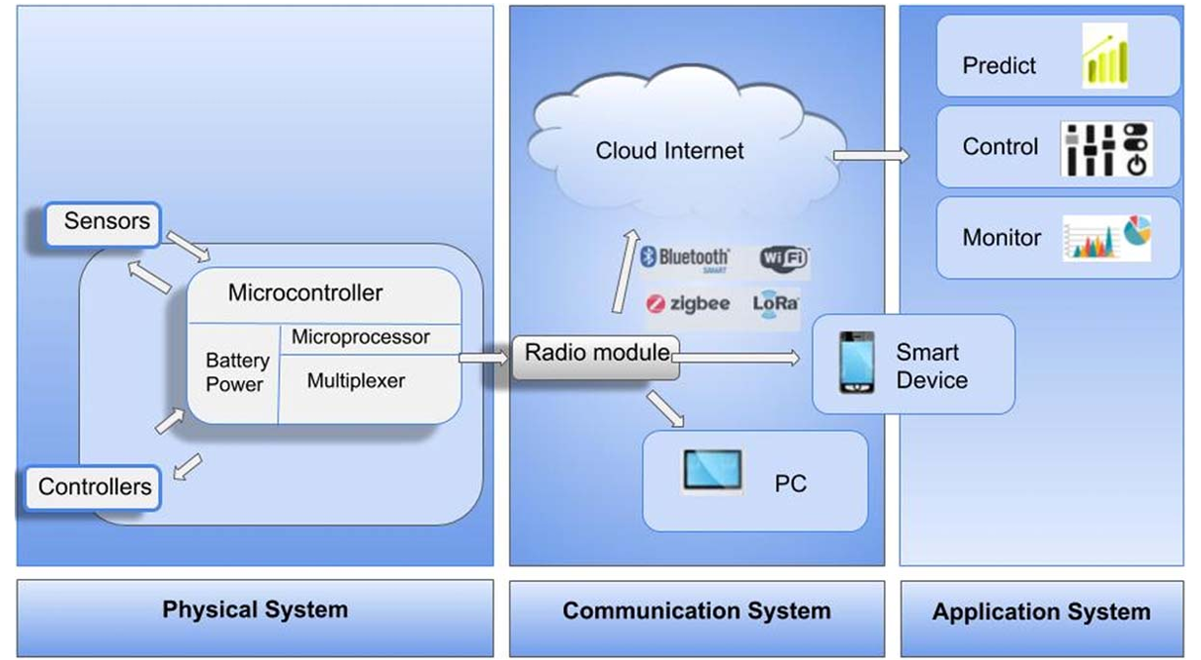

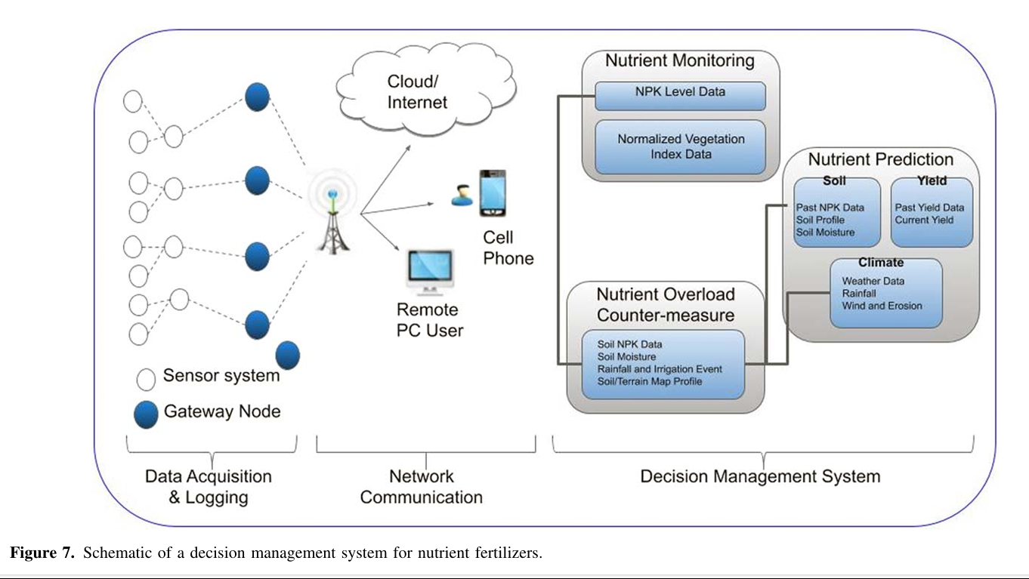

**TOOLS USED/IMPLEMENTED:-**

Soil Nutrient Sensors

Optical Sensors

Electrochemical Sensors

Vis-IR

ATR

Raman

ISFET

Ion Selective Electrode

**RESULTS AND DISCUSSION:-**

This would allow real-time monitoring and control of farm systems, thus making it easier for farmers to optimize production and minimize resource utilization. The literature identi f ies that due to the excessive utilization of fertilizers and pollution effects on the environment, a growing concern of pollution has warranted the need for technologies that can better monitor soil nutrients and their fate. The conventional laboratory methods may offer highly accurate analysis of soil chemistry, in situ based soil nutrient sensors that offer real-time feedback are needed in order to truly increase the efficiency of farming and managing the environ ment. As compared to conventional lab instruments for soil nutrient analysis, we find that in situ based sensors are more advantageous due to their low-cost, and high-density measurement capability for large-area soil nutrient mapping. Although these sensors are becoming less expensive to manufacture and can provide compar able results to laboratory soil analysis, there still exists a need to understand the effects of soil heterogeneity on the response of both optical and electrochemical sensors. More durable and accurate sensor systems that consider the effects of soils heterogeneity and offer soil specific calibrations are needed to move toward commer cializing these platforms. When interfaced with long-range low powered radio modules, these sensor platforms are able to imple ment real-time prediction, control, and decision management for large scale precision agricultural practices. As the saying goes, the revolution will be live! In the case of agriculture, the revolution will be real-time.

**IMPORTANT REFERENCE:-**

1. W. Willett et al., “Food in the anthropocene: the eat-lancet com-mission on healthy diets from sustainable food systems.” The Lancet, 393, 447 (2019).

2. Jan. 2020 World agricultural production, [https://apps.fas.usda.gov/psdonline/circu lars/production.pdf](https://apps.fas.usda.gov/psdonline/circu%20lars/production.pdf).

3. H. Charles et al., “Food security: the challenge of feeding 9 billion people.” Science, 327, 812 (2010).

4. W. J. Zhang, “Global pesticide use: profile, trend, cost/benefit and more.” Proc. Int. Acad. Ecol. Environ. Sci., 8, 1 (2018).

5. H.-J. Kim, K. A. Sudduth, and J. W. Hummel, “Soil macronutrient sensing for precision agriculture.” J. Environ. Monitor., 11, 1810 (2009).

6. K. A. Sudduth, J. W. Hummel, and S. J. Birrell, “Sensors for site-specific management.” in The State of Site-specific Management for Agriculture (ASA, CSSA, SSSA, Madison, WI) 10, 183 (1997).

7. V. I. Adamchuk, E. D. Lund, B. Sethuramasamyraja, M. T. Morgan, A. Dobermann, and D. B. Marx, “Direct measurement of soil chemical properties on-the-go using ion-selective electrodes.” Comput. Electron. Agric., 48, 272 (2005).

8. S. Laskar and S. Mukherjee, “Optical sensing methods for assessment of soil macronutrients and other properties for application in precision agriculture: a review.” ADBU J. Eng. Tech., 4, 206 (2016). 9. D. P. Schachtman and R. Shin, “Nutrient sensing and signaling: Npks.” Annu. Rev. Plant Biol., 58, 47 (2007).

10. M. H. Ward, R. R. Jones, J. D. Brender, T. M. De Kok, P. JWeyer, B. T. Nolan, C. M. Villanueva, and S. G. Van Breda, “Drinking water nitrate and human health: an updated review.” Int. J. Environ. Res. Public Health, 15, 1557 (2018).